Single root-tip RNA extract protocol Dec 2025
Extracting a usable quantity of RNA from single root tips has been difficult and so here we have done our best to come up with a reliable protocol that has been yielding ~10ng of RNA per tip. We have opted for an old school (and admittedly nasty) Trizol based extraction because any column or bead based extraction approach we have tried exhibit points where RNA can be lost (i.e. binding of RNA to silica membrane in columns or attachment to magnetic beads often only recover ~80% of recoverable RNA) and thus yield insufficient RNA for shotgun sequencing.
Opportunities for improvement lay primarily in tissue homogenization and mechanical lysis, as well as optimization of lysis volumes to minimize potential losses while increasing concentration. We first tried placing harvested root tips into empty 1.5ml tubes, dipping the bottom of the tubes in liquid N2, and then grinding with micropestles… However, the root tips are so small that they adhere strongly to the forceps and without some liquid in the tubes to “pull” root tips off of the forceps it was nearly impossible and far too time consuming. We also tried mechanical lysis with glass beads and “bead-bashing” in the trizol solution itself, but RNA yields were never detectable so I’m guessing we lost potential recoverable RNA through adherence to the beads. Likely the most effective way to conduct mechanical lysis will be to use a ultra-sonicator/tissuelyzer that has a small sterilizable tip which can be placed into 1.5ml tubes… but these tissuelyzers are very expensive.
For Library Prep we have been speaking with the Genomics Core at Duke and they recommended using the mRNA library prep kits from watchmaker genomics,
https://www.watchmakergenomics.com/rna-library-prep-solutions.html and the universal total RNA kit from Zymo for the total RNA seq with universal ribosome knockdown https://www.zymoresearch.com/products/zymo-seq-ribofree-total-rna-library-kit?srsltid=AfmBO oo7B61PXJ5w08l7a9dNX6DZQJBs8bNCGCitxgU-bvuuCMdDK1Ao
Sample Collection (From Soil Cores)
- Prepare 25ml of 1% Tween20 solution in 2 50ml Falcon Tube, and fill 4 50ml Falcon tubes with 25ml autoclaved water (3 tubes for rinsing roots, 1 tube for rinsing trizol off of forceps and scalpel)
- Prepare 10-20 1.5ml eppendorf tubes pre-filled with 100ul Trizol Solution and pre-label.
- Under a dissecting-microscope, set up a styrofoam container filled with ice, with a clean petri dish. Placing a glove under the petri dish allows for better visualization of the root tip.
- Collect soil core and separate into top and bottom half soil sections. While working with one section place the other in a clean petri dish on ice
- Place soil section into fine grain mesh strainer and gently rinse with DI water to remove excess soil from roots.
- Place roots in 50 mL Falcon tube with 25ml 1% Tween20, gently invert several times, then transfer roots with flame sterilized forceps into first Falcon tube with autoclaved water, invert and transfer to next tube. Repeat 2 more times.
- Using flame sterilized tweezers place some of the roots on the plate. Search for mycorrhizal root tips (will appear swollen and lighter than non-colonized root tips). Using sterile forceps and scalpel cut and pick off the root tip with a small amount of surrounding root. Place in a 1.5 mL tube with 100μL trizol reagent. Rinse extra trizol off of forceps and scalpel by dipping into autoclaved water prior to flame sterilization.
- After root tip collection for 15 minutes, repeat soil washing, rinsing, and root tip harvesting with the second soil section.
- After harvest, grind root tips stored in trizol using autoclaved micro-pestles. Wash pestle with 400ul additional Trizol to wash off residual tissue.
https://www.sigmaaldrich.com/US/en/product/sigma/baf199230001?utm_source=google &utm_medium=cpc&utm_campaign=23331190685&utm_content=194830326172&gad_ source=1&gad_campaignid=23331190685&gbraid=0AAAAAD8kLQR0MU_fuwLRqG_
9T-_siY4ZH&gclid=Cj0KCQiAjJTKBhCjARIsAIMC44-hXtvmeON4Dd5f_vq7wlEfZU YUgSP9Ytd7NIb6MjgKLyDlnyQWVM0aAn33EALw_wcB
- Place tubes in a sonicating bath and sonicate for at least 15 min to help facilitate cell disruption.
- Store ground and sonicated root tips at -70C until RNA extraction.
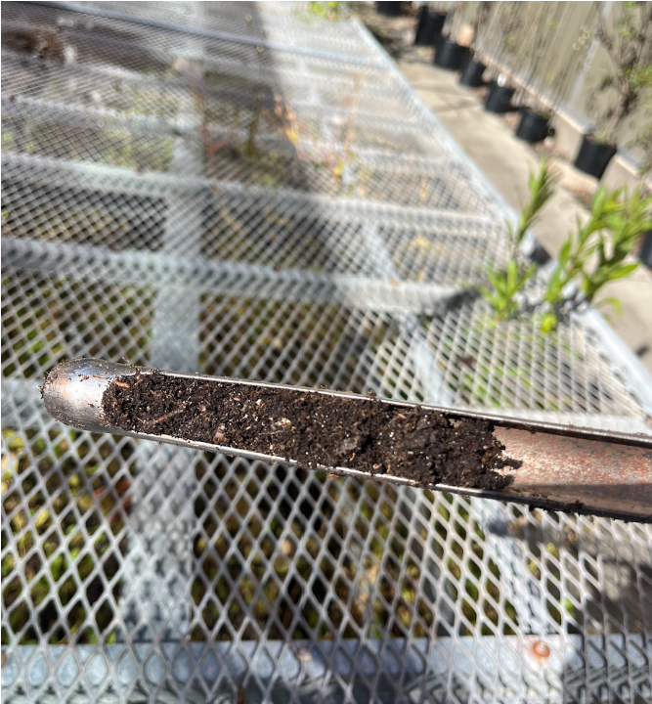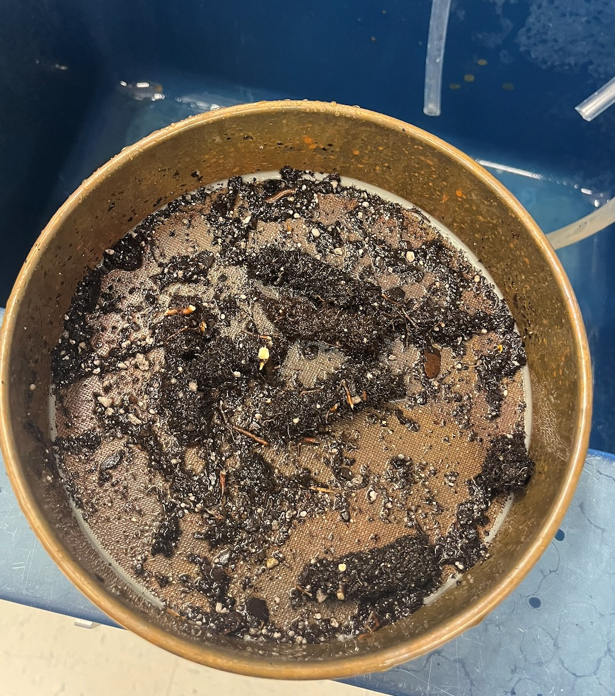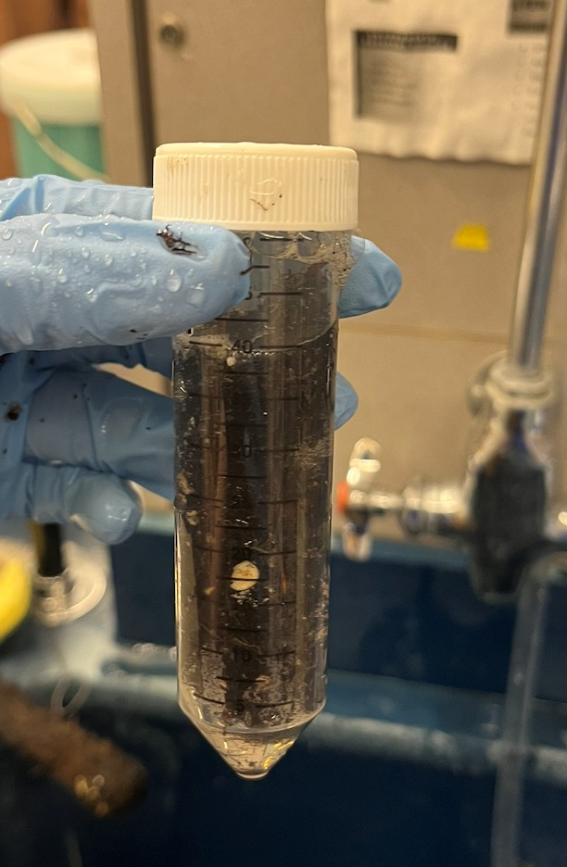

by
Core sample, step 1 Rinsing with sieve, step 2 Washing tube, step 3
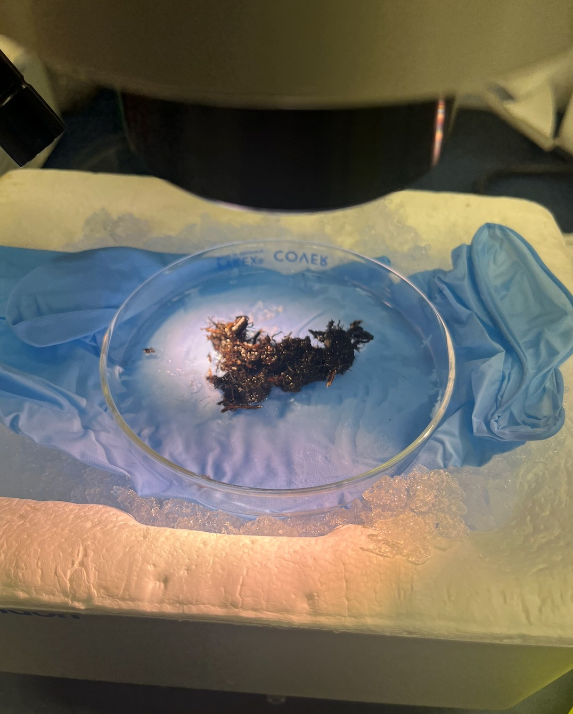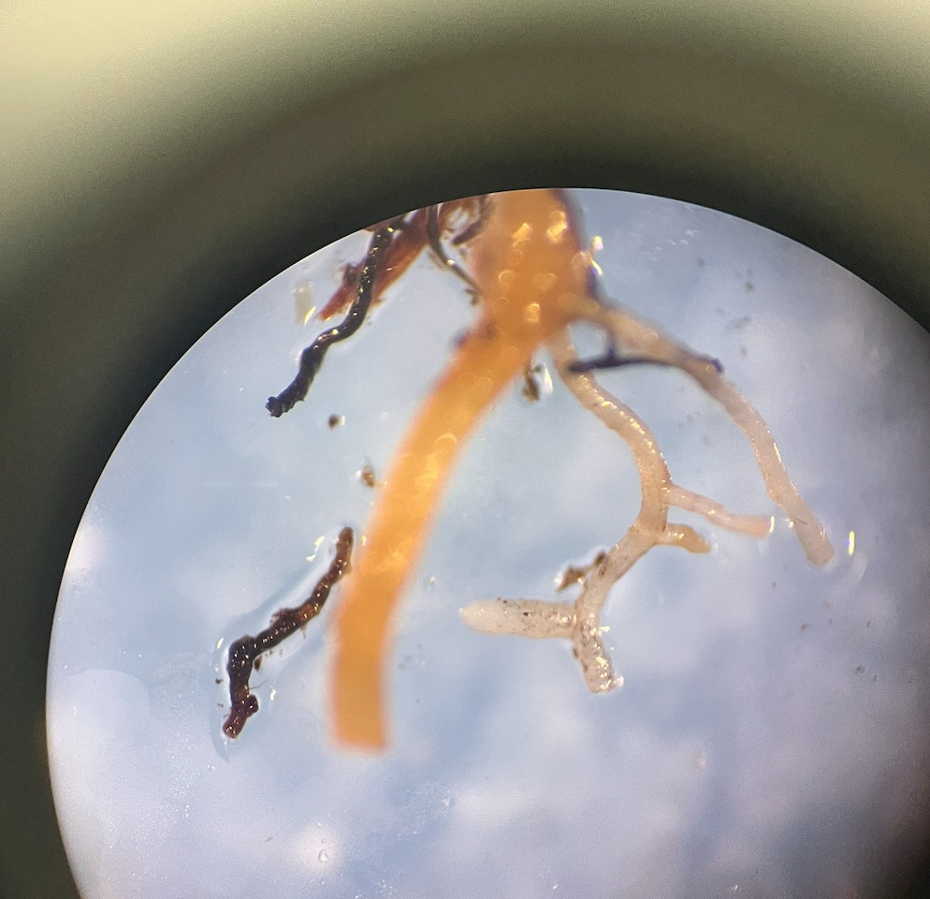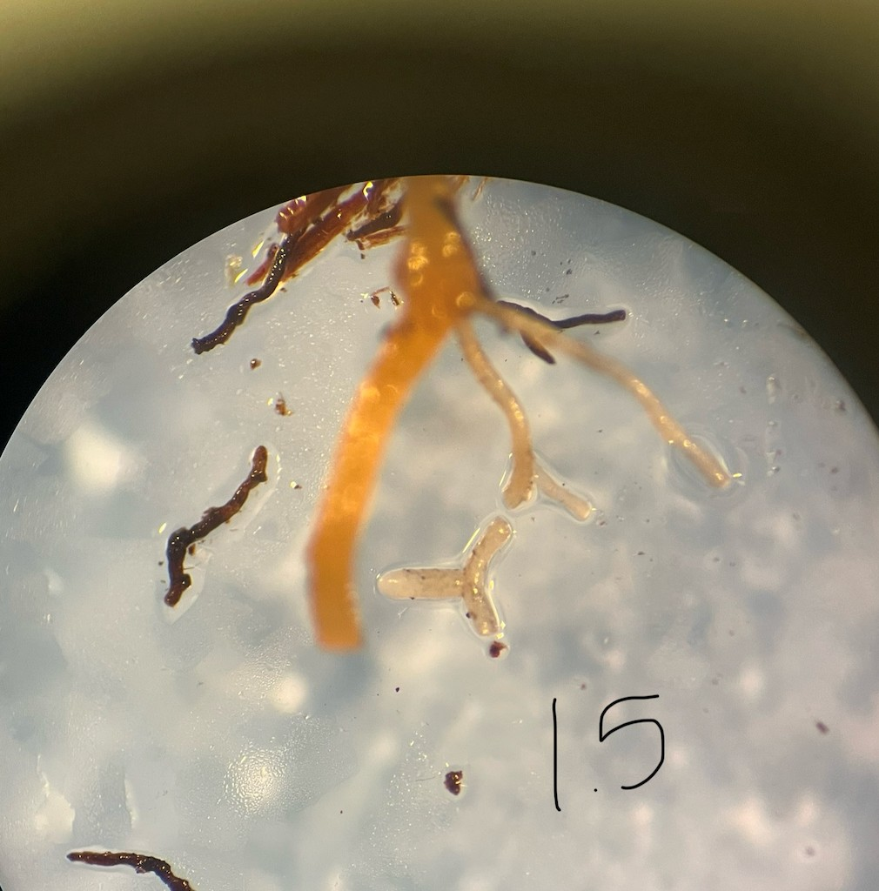
Petri dish set up, step 6 Amount of root taken from sample, step 7
Trizol RNA Extraction
  - Centrifuge at max for 3 min to pellet tissue debris, remove supernatant into a new tube.
a. These phase lock tubes can help increase yield and minimize phenol carry-over during extractions… but they are expensive… make sure to get the “heavy” formulation https://www.lifesct.com/PLG
  - Add 0.1 volume (50ul if you used 500ul starting volume) 1-bromo-3-chloroporpane, mix vigorously for 15 seconds and let sit for 15 min 0.2 VOLUME WHEN USING CHLOROFORM (100 ul if you used 500ul starting volume)
  - Centrifuge at 12,000g for 15 min at 4c
  - Retain colorless upper aqueous phase by tilting at 45 degrees and pipetting to transfer to another tube, avoiding any organic phase contamination. Retain the lower organic phase for later DNA and Protein precipitation.
  - Add 1 ul GlycoBlue to help low abundant RNA precipitate
a. https://www.thermofisher.com/order/catalog/product/AM9515
  - Add 0.5 volume (0.5 X 500ul of starting Tri-Reagent volume, so 250ul here) of
2-propanol (isopropanol), mix, let stand for 15 min
  - Centrifuge at 12,000g for 10min, pipette off the isopropanol while avoiding the RNA pellet
  - Wash the pellet by adding 75% EtOH (made with rnase-free reagents), 2x times, centrifuging for 5 min at 7,500g and pipetting off EtOH in-between
  - Let tube slightly dry, and then add 20ul of Rnase-free water + 1ul of RNase Inhibitor
a. https://www.neb.com/en-us/products/m0314-rnase-inhibitor-murine?srsltid=Afm BOorAeuRh-XxNmV28fbj1-6XCgxgKWS2uTBKIp3tpmoY4ZS8wPd2o
Nanopore Amplicon Barcoding of Full length ITS + 16S from non-dnased RNA extracts
ITS primers are ITS1F - ITS4R for Fungi, 27F - 1492R for 16S Bacteria
1) PCR Recipe (per sample) 25ul Reaction
    - Phusion 2 Hot Start Green Buffer 5ul
    - dNTPs 0.5ul
    - Primer 1 (10uM stock) 1.25ul
    - Primer 2 (10uM stock) 1.25ul
    - Phusion Hot Start 2 Polymerase 0.25ul
    - PNA blockers (ITS for ITS, mPNA for 16S) 1ul
    - Template DNA 1ul
    - Nuclease Free Water 14.75
2) PCR Cycle for NANO_ITS (600-900bp) using Phusion 2 HotStart Polymerase
    - Initial denaturation of 98 for 30 seconds
    - 30 cycles of:
i) Denaturation: 98°C for 10 seconds ii) Annealing: 55°C for 20 seconds iii) Extension: 72°C for 30 seconds
c) Final Extension: 72c for 5min
3) PCR Cycle for NANO_16S (~1.5kb) using Phusion 2 HotStart Polymerase
- Initial denaturation of 98 for 30 seconds
- 30 cycles of:
  - Denaturation: 98°C for 10 seconds
  - Annealing: 55°C for 20 seconds
  - Extension: 72°C for 45 seconds
- Final Extension: 72c for 7min

